R² is calculated using the formula given below
R² = (TSS – RSS) / TSS
- TSS = Σ (Y – Ym)²
- RSS = Σ (Y – Y^)²
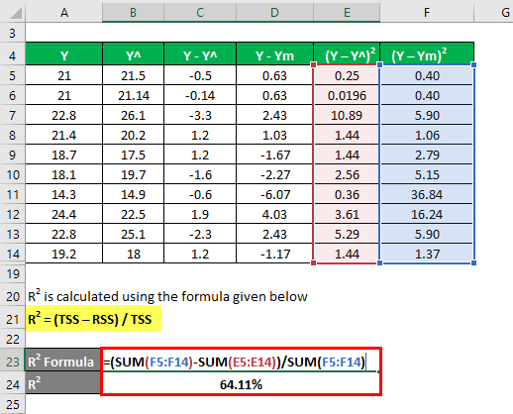
R² = 64.11%
Now let’s say we have 3 independent variables: i.e. k=3.
Adjusted R Squared is calculated using the formula given below
Adjusted R Squared = 1 – [((1 – R²) * (n – 1)) / (n – k – 1)]
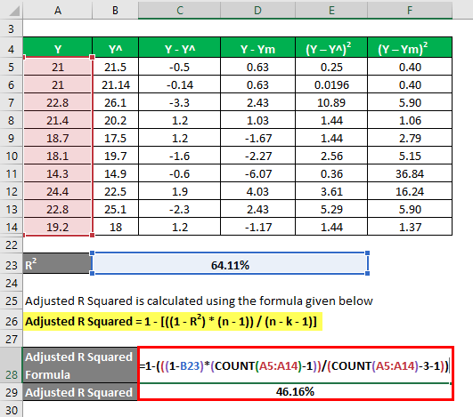

- Adjusted R Squared = 1 – (((1 – 64.11%) * (10-1)) / (10 – 3 – 1))
- Adjusted R Squared = 46.16%

Explanation
R² or Coefficient of determination, as explained above is the square of the correlation between 2 data sets. If R² is 0, it means that there is no correlation and independent variable cannot predict the value of the dependent variable. Similarly, if its value is 1, it means that independent variable will always be successful in predicting the dependent variable. But there are some limitations also. As the number of independent variable increase in the statistical model, the R² also increases whether that new variables make sense or not. That is the reason that adjusted r squared is calculated since it adjusts the R² value for that increase in a number of variables. Adjusted r squared value decrease if that independent variable is not significant and increases if that has significance.

